FIT2002 IT Project Management

OEU Hybrid Campus Case Study

Assignment 2 Report

**Assignment Team**

201

**Team Members**

Rounak Agarwal

Neerav Mehta

Timothy Correia-Paul

Laurence Andrews

**Date Submitted:**

14/01/2022

**Case Study Contents:**

**Running Case 5** **4**

Task 5.1.1: Risk Register 4

Task 5.1.2: Risk Score Estimation Rationale 8

Task 5.2: Risk Probability/Impact Matrix 10

Task 5.3: Risk Response Strategy 10

**Running Case 6** **13**

Task 6.1: Quality Standards & Requirements 13

Task 6.2: Measuring progress on the quality standards 15

Task 6.3: Outsourcing Memo 17

Task 6.4: Statement of Work 18

**Running Case 7** **21**

Task 7.1: Communications Management Plan 21

Task 7.2: Weekly Progress Report 26

Task 7.3: Communication Approaches for Tania 27

Task 7.4: Stakeholder management strategy 28

Task 7.5: Issue Log 31

**Appendix** **33**

Meeting Minutes 33

Timesheets 36

# Running Case 5

## Task 5.1.1: Risk Register

| **No.** | **Rank** | **Risk** | **Description** | **Category** | **Triggers** | **Root Cause** | **Potential Responses** | **Risk Owner** | **Probability** | **Impact** | **Status** | **Score** |
| --- | --- | --- | --- | --- | --- | --- | --- | --- | --- | --- | --- | --- |
| R01 | 8 | Increased Workload | Current academic and administrative staff are concerned about increased workload | People risk | Requirement of new study material for online education | Lack of staff | **Mitigation:**  Hiring skilled staff | Dean of University, Head of individual departments | 7 | 2 | open | 14 |
| R02 | 4 | Technical Delay | Delay in the activation of the broadband | Technology risk | Technical difficulties and poor service | Lack of research and poor estimation of work | **Mitigation:**  Divide team into subgroups so that we can simultaneously test all locations, so that even if one location is having the problem it won't affect the scheduling of other study centres | OEU Manage-ment | 7 | 5 | open | 35 |
| R03 | 7 | Staff Leaving during the project | Glenda Brown, the registrar of the university, left after the project commenced. | People risk | Increased workload and dissatisfied with the work | lack of communication between the staff and the higher officials | **Contracts**:  Including a notice period | OEU Manage-ment | 3 | 6 | open | 18 |
| R04 | 1 | Educational accreditation | Some local accreditation body refuses to accredit a hybrid campus (only  physical campuses can be accredited). | Structure/  process risk | untypical mode of education | Lack of proper education in eyes of policy makers | **Transference:**  Prepare a defence attorney | OEU Manage-ment and the Students | 5 | 9 | open | 45 |
| R05 | 2 | Technical Issues | Some areas just have low reach of a good internet | Technology risk | Study centres in remote areas can have this issue | Not enough research done on the connectivity while evaluating property | **Transference**:  Tie up with a broadband company to resolve the issue  **Mitigation**:  Get a new place for the study centre as a last resort | OEU Manage-ment | 7 | 6 | open | 42 |
| R06 | 6 | Adaptivity | - Students and Teachers need to adapt to the new teaching dynamics | People risk | Transition from in-person classes to hybrid/online classes | Lack of in person interaction with the tutor | **Acceptance**:  Ask students for reviews and suggestions that could make the adaptivity process easier | OEU Manage-ment and the Students | 8 | 3 | open | 24 |
| R07 | 4 | New employee training | Lack of proper training provided to the new employees regarding this mode of education | People risk | unable to provide proper training to new staffs | - Lack of funds assigned for the task  Lack of time | **Mitigation**:  Allocate funds to provide proper training to staffs | OEU Manage-ment | 7 | 5 | open | 35 |
| R08 | 10 | Government Subsidy | Government funding the project to support local business | Financial risk | getting a head start at unorthodox methods of teaching | It encourages people to complete tertiary education through newer modes of education | **Risk Enhancement**: use the funds to open more study centres and advertise university | OEU Management | 1 | 7 | open | 7 |
| R09 | 9 | Workplace injury | Staff getting injured during construction or renovation | People risk | carelessness/ accidents | Lack of proper information or training, unsafe systems of work, poorly maintained or unsuitable equipment, poor planning, unclear responsibilities, poor supervision. | **Mitigation**: proper supervision, proper training | Workers, students | 3 | 3 | open | 9 |
| R10 | 3 | New competition | Another university or universities also begin their own hybrid campus project, leading to increased competition and lower revenue / profits. | Market risk | - potential success of our university, others try to replicate the process | demand for this mode of education | **Avoidance**: Increased marketing, providing more competitive fee rates | OEU Management | 8 | 5 | open | 40 |
| R11 | 2 | Low enrolment | The demand for hybrid campus degrees is too low. | Structure/  process risk | unorthodox mode of education | Lack of in person interaction with the tutor/lecturer | **Avoidance**:Increased marketing,  **Mitigation**: closing underutilised study centres | OEU Management | 6 | 7 | open | 42 |
| R12 | 4 | Too high enrolment | The demand for hybrid campus degrees is too high, such that the 10 new study centres are not sufficient to meet the demand of all the students who have enrolled. | Structure/  process risk | unorthodox mode of education | More interactive form of learning/ word-of-mouth | **Risk Enhancement**: Plan in place for building additional hybrid campus study centres | OEU Management | 5 | 7 | open | 35 |

## Task 5.1.2: Risk Score Estimation Rationale

### Risk R01: Increased Workload

We have assigned a probability of 7 for increased workload as students won't be able to keep up with the study materials which were used for non-hybrid campuses. However, the impact is set at 2 i.e. is very low as the risk owners won't really be that affected by it.

### Risk R02: Technical Delay

The chances of it happening is high as the chances of some technical issues due to delay in the activation of the broadband connection is very likely. Since this campus is dependent on the internet the impact would be medium.

### Risk R03: Staff Leaving the during project

The probability of staff leaving during the project is low as people rarely leave in the middle of an assigned work. The impact would be high if a staff member decides to leave the place during the project as they were trained for this particular project.

### Risk R04: Educational accreditation

The chances of a local body refusing to acceridate the courses in this campus is medium due to the fact that it uses a very unorthodox mode of learning. The impact is very high as the number of students enrolling will completely depend on the course accreditation.

### Risk R05: Technical Issues

The chances of it happening is high as the chances of some technical issues due to poor internet connection is very likely. Since this campus is dependent on the internet the impact would be also high.

### Risk R06: Adaptivity

The probability of students not being able to adapt to this new mode of education is very high as students don't usually study under these conditions. However, the impact is low as it will not really affect the management.

### Risk R07: New Employee training

The risk of no proper training provided to the new employees is high as there are no funds allocated for this. Due to this, it would cause a medium impact on the management.

### 

### Risk R08: Government subsidy

The chances of the government providing a subsidy to study at these campuses is very low as these are privately owned universities. But, if the university agrees to provide subsidies to the students studying here, it would encourage many students to enroll here causing a high impact.

### Risk R09: Workplace injury

The chances of a workplace injury is low as one doesn't really have to do anything physical whilst at the campus. In the event of a workplace injury the impact would be low as well as it wouldn't really affect the management much.

### Risk R10: New competition

The chances of a new competition emerging is very high as other investors will be looking at the demand for this mode of education. In the event it occurs, the impact would be medium on the management as by the time they have a new competition, they will have set up their own monopoly.

### Risk R11: Low enrolment

The chances of having a low enrolment is high as students might not want to transfer to an unorthodox mode of education. The impact would be high as well as it will cause the management heavy loss.

### Risk R12: High Enrolment

The chances of having too high enrolment is medium as the student might want to try a newer and more comfortable mode of education. The impact would be high as the university will have to plan and make more new campuses such as these.

# 

## Task 5.2: Risk Probability/Impact Matrix

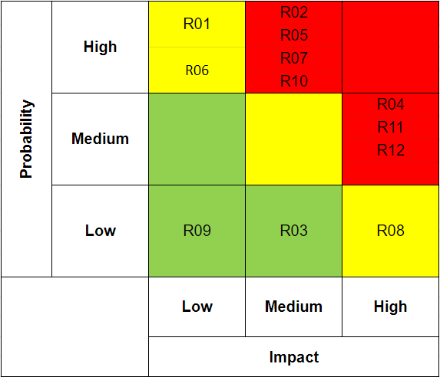

## Task 5.3: Risk Response Strategy

### Risk R01: Increased Workload

It is expected that in a huge project like this we underestimate the amount of work that is needed to be done. Hence, the current academic and administrative staff are also concerned about the increased workload. In order to address this risk at the time considering the circumstances, it has been decided that if the staff feels that they are short handed, then OEU university will put out an application to hire skilled staff or interns as per the requirement. There would be feedback taken from the staff as well before and during the recruitment process to ensure that the issue is solved.

### Risk R02: Technical Delay

Considering the project is highly dependent on internet broadband activation delay would be a major risk every time it happens. The first few times we would have to cancel the class/ and provide students with alternate class timings or recorded lectures. But if the issue is persistent we would have to have an IT team present at every study centre to fix the issue right there.

### Risk R03: Staff Leaving the during project

During the project, there is a possibility that an employee would want to quit their job due to personal/ professional reasons. In order to handle this the management has provided a contract to each employee before joining to have a notice period of at least two weeks to ensure a smooth transition and hand over of employee work to the new employee. To ensure that other employees are not demotivated by this an announcement would be made describing the reason and circumstances under which the said employee is leaving the company.

### Risk R04: Educational accreditation

Considering hybrid campuses are a new concept in the education sector, there is a possibility that some local accreditation bodies might refuse to accredit a hybrid campus. In such a circumstance the management has decided that they won’t give up on this idea, hence they have planned to challenge that using the university’s attorney team, but have also planned to relocate in-case things don't go as expected.

### Risk R05: Technical Issues

In a project which highly depends on a good network connection, there is a possibility that we encounter some issues with connectivity. Hence, it is understandable that the team might have a technical delay in the entire project because of poor connectivity in certain study centre locations. To avoid that we would divide the team into subgroups so that we can simultaneously test all locations, so that even if one location is having the problem it won't affect the scheduling of other study centres. And if one location is having said problems we would plan to migrate more members in-order to solve the problem as quickly as possible.

### Risk R06: Adaptivity

As the concept of hybrid campus is fresh for both students and teachers, they would be required to adapt to this new method of teaching. This transition could be easier if we provide some training to the teachers. During the first year the teachers and the dean have decided to take regular feedback from the students in order to make it the best experience for the students at OEU. The feedback will be taken online every two weeks anonymously, so that students can feel free to express their opinions. Other than the teachers will also try and take regular informal feedback from the students.

### Risk R07: New Employee

The project might require hiring employees in between the project for multiple reasons such as staff feeling overload, staff leaving, or just a new vacancy for a position that wasn’t filled before. The common way to handle this would be to provide them with training modules. If an employee is replacing a previous staff member, as per the contract the previous employee would train the new employee for the 2-weeks period before leaving.

### Risk R08: Government Subsidy

Considering this unorthodox method might promote tertiary education among students and help local community areas function. The local accreditation authorities might see this as an opportunity to promote education in the country, hence funding the project using the subsidy. We plan to use the money depending on the amount to promote the concept of OEU’s hybrid campuses, and open new study centres and studios.

### Risk R09: Workplace Injury

Staff getting injured is uncommon in an academic facility but during the construction process it might be a little more common than usual. In a common accident with low risk such as a paper cut, or a minor cut- a government accredited first aid kit would be present at each facility. In case of a serious or life-threatening situation the supervisors are instructed to go through the company’s safety procedure which includes calling 000 and utilise their First Aid training if required.

### Risk R10: New Competition

Considering this a new concept, there is a possibility that other established universities might try to replicate the process, in such a case a strategic marketing team would be employed to help with the enrollment and figure out new methods to fight the competition.

### Risk R11: Low Enrolment

As hybrid campuses are a new concept there is a possibility that students are hesitant to enrol in said campuses. We would try to get better marketing, one-on-one enrollment sessions to convince the students about the benefits and open quarterly enrollment so that students don’t need for the end of the semester to enrol.

### Risk R12: High Enrolment

In case of too high enrolment that would fill the capacities of all our study centres a fast track process to open multiple study centres in a short period of time would be taken into account and students would be provided with an option to join the waiting list. There is a possibility we might give the students access to study at home so they don’t miss the studies during the time the new study centres are available.

# Running Case 6

## Task 6.1: Quality Standards & Requirements

| **Item #** | **Quality Standard /**  **Requirement** | **Stakeholder Information &**  **Requirement Information** |
| --- | --- | --- |
| **1** | **A high quality product:**  The hybrid campus education product must be high in quality. | Stakeholders including the project’s sponsor and senior management at OEU are most concerned with the hybrid campus project delivering a high quality, but affordable product.  In order to ensure that the education product is of high quality, hybrid campus students will take the same assessments as regular campus students. By comparing the assessment scores of the two cohorts. By doing so, the quality of the hybrid campus education can be objectively monitored. Hybrid campus average results must be no lower than 5% below normal campus results. If hybrid campus students achieve worse average results on the exams, changes will need to be made to improve the quality of the education product. |
| **2** | **An affordable product offering:**  The hybrid campus education product must be affordable in order to be competitive in the online education market. | Stakeholders including the project’s sponsor and senior management at OEU are most concerned with the hybrid campus project delivering a high quality, but affordable product.  As many costs associated with a physical campus are not present in the hybrid campus, the hybrid campus degree can be priced lower than a traditional degree while still maintaining profitability. While accounting for costs and profitability, the price of the hybrid campus degree must always be kept lower than the price of the equivalent physical campus degree. |
| **3** | **Well-distributed study centre locations:**  Study centres should be distributed. They should be located in areas where the demands for OEU's qualifications are significant, but where little to no competition exists. | Top management stakeholders specifically expect this requirement for the project.  Study centres should be in locations with a demand for higher education, such as those with few tertiary education centres. The location should have 2 or fewer university campuses, or have a significantly larger demand for education than the current supply. |
| **4** | **Study Centre IT & Infrastructure Requirements:**  Each study centre will have one video conferencing venue that can seat 50 students. The video conferencing equipment for each study centre should include two large television screens, a camera, speakers and a microphone. The study centre will need broadband access to the internet. A computer with a document scanner will also be needed. Each studio should be equipped with a camera, computer (for presentation aids), the necessary presentation and video conferencing software and two television screens. | Top management stakeholders specifically expect this requirement for the project.  Study centres will be defined as functional if they meet the following requirements:   * Seating and desks for sitting 50 students in the room * video conferencing equipment, including * 2 large Screens, a camera, speakers, a microphone * Broadband internet connection * A computer with a working document scanner * A computer for presentation aids * Presentation and video conferencing software |
| **5** | **Real-time interactive lecturing internet capabilities:**  Students should be able to ask questions and interact with the lecturer. Lecturers should be able to see live footage of every study centre forming part of a particular lecture. | Top management stakeholders specifically expect this requirement for the project.  Interactive capabilities should be present during lectures, allowing two-way communication. lecturers and students can view, communicate and interact with each other in real time. The maximum communication delay between central hub and study centres should be within 1 second nationally, and within 2 seconds internationally. |
| **6** | **Functional Student Learning Management System:**  A student management/ support system (such as Moodle) should be implemented for support and assessments. | Top management stakeholders specifically expect this requirement for the project.  The student learning management system should be designed. An existing product (such as Moodle) may be used, but it should be adapted for the particular university. The student learning management system should be used for all in-semester assessments, course work and notices. The student learning management system will be online during all business hours, as well as being online at least 90% of non-business hours. Scheduled maintenance should only occur within the hours of 2:00am - 6:00am. |

## Task 6.2: Measuring progress on the quality standards

| **Item #** | **Quality Standard /**  **Requirement** | **Progress Measure Used** |
| --- | --- | --- |
| **1** | **A high quality product** | All assessments, including exams will be the same for hybrid campus degrees and physical campus degrees. To avoid bias when marking assessments, examiners will mark the assessments of both cohorts of students at the same time, and the cohort of each student will not be revealed.  After marking, assessment results will be automatically retrieved and analysed using OEU software. Top management and the hybrid campus administration will be automatically notified if the average mark of the hybrid campus cohort drops 5% lower than the physical campus cohort. |
| **2** | **An affordable product offering** | The cost of OEU degrees is already being measured and analyzed regularly by the business team.  While accounting for costs and profitability, the price of the hybrid campus degree must never exceed 80% of the price of the equivalent degree at an OEU campus. |
| **3** | **Well-distributed study centre locations** | For each area eligible for a study centre, predictors of higher education demand, such as the number of high school graduates and other eligible students will be recorded and analyzed. The areas with the largest discrepancies between demand and supply will be proposed as locations for study centres.  If 2 or more universities exist within a 5km radius of the proposed location, then the location is ineligible for a hybrid campus, this will be calculated by management during location scouting. |
| **4** | **Study Centre IT & Infrastructure Requirements** | Study centres will be monitored for equipment by using an automated reporting system.  Each study centre will contain spare supplies for all physical equipment and hardware, so it can be immediately replaced within 24 hours of reporting. For equipment or services requiring a specialist to fix, the centre manager keeps a list of business contacts of any local specialists that may be required to call in. |
| **5** | **Real-time interactive lecturing internet capabilities** | Full internet capability is expected to be observed at least 99% of the time during business hours. An automated system will record the internet connection quality between the central hub and study studios. The system will automatically notify the hybrid campus administration if:   * The internet connection breaks. * The delay between the central hub and national study studios exceeds 1 second. * The delay between the central hub and international study studios exceeds 2 seconds. |
| **6** | **Functional Student Learning Management System** | Student learning management system (SLMS) service providers and platforms will be reviewed for meeting the quality standards specified by the SLMS team. During a meeting with the SLMS team and internal OEU stakeholders, the platforms will be discussed and the chosen platform will be selected.  The student learning management system will be online during all business hours, as well as during 90% of non-business hours, with the only exception being during scheduled maintenance between 2:00am and 6:00am. An automated reporting system will monitor the system and notify the hybrid campus administration if the system becomes unavailable. |

## Task 6.3: Outsourcing Memo

Dear OEU Hybrid Campus Management Team,

Upon internal discussion and research into the source of training, we agree that it makes the most sense to outsource your training needs. We will be in contact with some specialized training providers with worldwide experience to provide OEU with uniform and high quality training.

There are several key advantages to outsourcing which relate to both the cost and quality of the training. Firstly, a training provider is an organization that is completely geared towards providing training so they have working systems in place and proven results. The time, costs and risks necessary for OEU to create a training infrastructure make it a difficult task to complete quickly and to a high standard. Outsourcing the work will allow OEU not to worry about further hiring employees and developing infrastructure, giving more time to focus on creating the optimal education product. The training provider will be able to liaise with OEU on training specifics but will handle the bulk of the work.

Since the training requires an in person element at over 30 different locations around the world it is much cheaper to pay the training provider to send trainers around their continent instead of OEU sending trainers around the entire world. The flexibility of the suggested contract is also very beneficial to OEU, it allows for the proposed training to be trialled out and not completely committed to. OEU can monitor the quality of the training and can even opt to develop its own training program if they deem it an easy task.

There are of course some potential drawbacks to outsourcing, namely in terms of OEU’s control over the training and its effect on the overall quality. The training provider will have discretion to make all kinds of decisions about training without much oversight from OEU, as this would be too time consuming. OEU must trust that the training provider will make the right decisions as it will often be difficult to convince the provider from changing their tried and tested methods. These are of course only potential drawbacks, this is because they rely on the quality of the training provider itself. If OEU is able to employ a training provider with a strong reputation for delivering a quality training service then a lack of oversight from OEU’s behalf will not matter.

Clearly there are many advantages to outsourcing the training program, and with the right training provider, there are very few real drawbacks. OEU must devote resources to making sure that the right training provider is found which suits OEU’s complex geographical and time-oriented needs. As this training will form the basis of the quality of the first semester of OEU’s hybrid campus product, it is vital that it is as problem free as possible.

Kind Regards,

Laurence Andrews.

## Task 6.4: Statement of Work

### Scope of Work

OEU seeks a training team to provide training for their hybrid campuses. This includes training of centre managers, support staff, and students. The training requirements for each of these groups are as follows:

#### Training of study centre managers

Training for study centre managers will include technical and education-related training. Training will be delivered in-person, on-site at each of EOU’s study centres. Video training and a training manual will also be developed. Training for centre managers will be on-site, meaning it will take place at 30 locations around the globe. The scope of deliverables for training study centre managers shall include technical training for using, managing and/or maintaining:

* All physical equipment required or used within the study centre,
* All hardware and software required or used within the study centre,
* All soft-skills and education-related training and skills used for managing the study centre, as well as for managing, working with and disciplining students,
* A training manual containing the full contents of the training programme for ,
* A library of video training and tutorials organised by topic-specific references.

#### Training of technical support staff

Technical support staff will be trained for assisting students experiencing technical difficulties via customer support training. Training of technical support staff shall take place online via the video conferencing platform Zoom, and will take place in a group setting. The scope of deliverables for training technical support staff shall include technical training required for:

* All hardware and software required by or used within the study centre, the central hub, and by students,
* All customer support skills and soft skills used for assisting students and study centre managers,
* All technical support skills required for assisting students via email, phone calls, and live chat discussions.
* The training must cover all aspects of the system, technical issues, and customer support.
* A training manual containing the full contents of the training programme for technical support staff,
* A library of video training and tutorials organised by topic-specific references.

#### Training of students

Students will attend a two-day orientation in which they are introduced to the hybrid campus system. During this orientation, the students will be provided with a 3-hour, Zoom-based technical training for using the system. The scope of deliverables for training students shall include technical training required for:

* All software required by or used by students within the hybrid campus system
* A training manual containing the full contents of the training programme for students,
* A library of video training and tutorials organised by topic-specific references.

### Location of Work

Note that training of centre managers will be taking place in-person and on-site at EOU study centres. These trainings will take place in 30 of our study centre locations, including national *and* international locations.

* Training for centre managers will take place at the study centres, of which there are 30 locations around the world. The countries of these study centres are: USA, Canada, UK, EU, Australia, China, India, and South Africa.
* Training for technical support staff and students will take place virtually over Zoom.

### Period of Performance

Training will occur each semester, for centre managers, technical support staff and students. The duration of the contract is 1 month. The date of commencement shall be 01/02/2022, and the date of completion shall be 01/03/2022. Currently, 1 contract is available for tender. If the provided service is satisfactory in standards, then additional contracts will be on offer on a semesterly basis. These contracts will all be 1 month in duration, and with commencement dates of which will correspond with the beginning of each OEU semester period.

### Deliverables Schedule

| **Item No** | **Item Description** | **Date by** |
| --- | --- | --- |
| 1.1 | Completion and delivery of the training manual for centre managers. | 14/02/2022 |
| 1.2 | Completion and delivery of the training manual for technical support staff. | 14/02/2022 |
| 1.3 | Completion and delivery of the training manual for students. | 14/02/2022 |
| 2.1 | Completion and delivery of the video library of training and tutorials for centre managers. | 21/02/2022 |
| 2.2 | Completion and delivery of the video library of training and tutorials for technical support staff. | 21/02/2022 |
| 2.3 | Completion and delivery of the video library of training and tutorials for students. | 21/02/2022 |
| 3.1 | Completion and delivery of the training workshop for technical support staff. | 28/02/2022 |
| 3.2 | Completion and delivery of the training workshop for centre managers. | 01/02/2022 |
| 3.3 | Completion and delivery of the training workshop for students. | 01/03/2022 |

### Applicable Standards

Applicable standards include:

* Australian Professional Standards for Teachers (APST)
* National Vocational Education and Training Regulator Act 2011
* VET Quality Framework which means:
  + Standards for Registered Training Organisations (RTOs) 2015
  + Fit and Proper Person Requirements 2011
  + Data Provision Requirements 2012
  + Australian Qualifications Framework
  + Financial Viability Risk Assessment Requirements

### Acceptance Criteria

On 14/02/2022 and 21/02/2022, OEU will review the due deliverables for satisfactoriness. These deliverables will be the basis for the online and in-person training to be held between 21/02/2022 and 01/03/2022.

The quality of the deliverables must meet the standards referred to in the standards section to be approved as satisfactory during the reviewing process.

### Special Requirements/Miscellaneous

All personnel responsible for signing off on the deliverables and presenting the training workshops are required to have at least one of the following qualifications/certifications:

* A Bachelor degree or higher in education or an equivalent field.
* Certified Professional in Talent Development (CPTD).
* The Certified Professional in Training Management (CPTM).

### Type of Contract & Payment Schedule

The work will be a 1 month contract.

The payment schedule will be as follows: 50% paid upfront on 01/02/2022, 50% paid at the end of the contract period on 01/03/2022, assuming satisfactory completion of the project deliverables are met. If satisfactory completion of the project deliverables are not met by the conclusion of the contract, the second payment will be delayed until satisfactory completion of the project deliverables.

# 

# Running Case 7

## Task 7.1: Communications Management Plan

### Communications Management Approach

The OEU Hybrid Campus project is a large-scale project which reaches many corners of the globe. Effective and efficient communication at every scale of the project is necessary, both in the project's development and its entire lifetime. The communications matrix, found below, details the communication protocol as it is at this point in time; it is of course subject to change as a result of internal and external factors.

Face to face meetings are highly effective but at some layers of this project also very impractical. Where face to face meetings aren’t possible, video conferencing will be used as a substitute. A combination of email and business communication platforms such as Microsoft Teams will be utilized to hash out the finer details of various parts of the project.

As stated above, all communications are subject to change but will follow a formal process to do so. Communication methods may change due to reasons such as changes in staff, budget, changes in the direction of the project and changes in and around staffed locations. A change, once suggested to the project manager, will become an item during the next meeting during which all relevant parties are present. If it is deemed that the change will result in a net benefit to the communication process, it will be approved by the project manager. The communications plan and other relevant documentation will be updated and all affected parties will receive digital copies of the new plan and a summary of the changes.

# 

# 

### 

### Communication Methods and Technologies

OEU’s organizational policy states the specifications relevant to communications channels used for all activities and processes. This includes policy stating the various reasons for using each of the available communication methods and technologies.

OEU utilises an organization-based Microsoft Teams account for communication and updates. Using Microsoft Teams, all members of EOU, including the executive management team, general management, stakeholders and project members are able to access communications and project files, and communicate within the organization at all times. If Microsoft Teams becomes unavailable or inaccessible to any project member at any point in time, all the project documents on Microsoft Teams are automatically backed up through EOU’s Google Drive, which all members are able access for retrieving project documents. Furthermore, while Microsoft Teams remains unavailable, email shall be used as the secondary communication method for all personal and group communication.

Asana is the software used for schedule management and task management in OEU projects. As such, Asana is used for documenting, maintaining, and communicating project schedules to project members and other stakeholders. Asana is also backed up through integration with Microsoft Teams and Google Drive, allowing members to view project schedules and related documents through Microsoft Teams and/or Google Drive as secondary channels if Asana becomes unavailable to any project member or stakeholder.

OEU organizational policy specifies the organization-wide policy specifications relevant to file management, including file naming and organisation. These file management standards shall be applied consistently across all the three platforms used for project communication and documentation (i.e. Microsoft Teams, Google Drive, and Asana).

### Communications Matrix

| **Communication Type** | **Objective of Communication** | **Medium** | **Frequency** | **Audience** | **Owner** | **Deliverable** | **Format** |
| --- | --- | --- | --- | --- | --- | --- | --- |
| Informal Introductory meeting | Introduce the project team and project to the new members. Review project objectives and management approach. | - Preferably Face to Face  - Conference call (as needed) | Once | - Project Team  - Stakeholders | Project Manager | Meeting Minutes  Agenda  New member/s added to Oodle | The Microsoft Team and Asana for the respective team would have an archive of all the work done during the meeting |
| Regular team meetings | Discuss the project's progress. Anything that requires Project Manager's attention is addressed in these meetings including budgets and scheduling of the project | - Preferably Face to Face  - Conference call (Depending on the circumstances) | Weekly | - Project Team  - Project Manager | Project Manager | * Agenda * Meeting Minutes | The Microsoft Team and Asana for the respective team would have an archive of all the work done during the meeting |
| Technology Team Meetings | The project requires technical solutions, which are identified, discussed, and developed. | - Face to Face | Whenever necessary | Staff involved in project technical aspects | Lead technical analyst | * Agenda * Meeting Minutes | The Microsoft Team and Asana for the respective team would have an archive of all the work done during the meeting |
| Project Progress Meeting | Present management with a status report on the project. | - Face to Face  - Conference Call | Monthly | - Respective Team Leads  - Project Management Team | Project Manager | * Current Project Report * Presentation by each team leads | The Microsoft Team and Asana for the respective team would have an archive of all the work done during the meeting |
| A Status Report on the Project | Give an update on the project's status, including activities, progress, costs, and issues. | - Microsoft Teams  - Asana  - Weekly Updates on emails | Weekly | - Everyone involved in the project | Project Manager | * Project Status Report * Project schedule | The Microsoft Team and Asana for the respective team would have an archive of all the work done during the meeting |

### Communication Escalation Process

The OEU Hybrid Campus project, like any other project, has its share of disagreements and conflicts. Conflicts can be tackled with escalation models that provide a framework to deal with these issues, so that the project remains on its schedule. Below is a table that outlines the priority levels, decision authorities, and deadlines for resolutions.

| **Priority** | **Definition** | **Decision Authority** | **Timeframe for Resolution** |
| --- | --- | --- | --- |
| Priority 1 | Face to face communications of managers by flying to each campus for regular communication | OEU Management | Within 1 business week |
| Priority 2 | Better communication between the staff handling the videoconferencing tech. | OEU Management | Within ten business days |
| Priority 3 | Proper reporting of the weekly status report specially addressing the obvious changes. | OEU Management | Within two business weeks |
| Priority 4 | Need for communication over the different time zones, cultures, languages, geographical areas | OEU teaching staff | Work continues and any recommendations are submitted via the project change control process |

# 

## Task 7.2: Weekly Progress Report

| **Project Name** | Hybrid Campus |
| --- | --- |
| **Team Member Name** | Rounak Agarwal, agarwal.rounak@outlook.com |
| **Date** | 03/01/2022 |
| **Work completed this week** | * Held an introductory meeting for Nicole, the new registrar, to on board her onto the project. * Scheduled a meeting with the project manager, Stephanie and Tania, to resolve the issues occurring in the videoconferencing team. * Created accounts for the new project members on Microsoft Teams, Google Drive, and Asana * Had a meeting with the OEU staff to encourage discussions. * Spoke to the OEU management to resolve the face to face communication issue. * Organised an Accreditation Task Force team in order to effectively manage the project's accreditation requirements for all relevant countries. |
| **Work to complete next week** | * Continue work on improving discussions. * Develop new cost estimates for outsourced work. * Approach the accreditation regulatory boards of different countries to accredit the courses. |
| **What's going well and why?** | The project is on schedule with no major issues and very less budget deflection as all the departments followed the project schedule. |
| **What's not going well and why?** | The communication in between the staff working in the videoconferencing department due to the lack of proper training modules and guidelines. |
| **Suggestions/Issues** | * Get some sample contracts and help in negotiating with the preferred supplier. * Get a new set of training modules for proper guide training. |
| **Project Changes** | I think we can stay on schedule but we will need some more money for the training of the new hired staff. |

# 

## Task 7.3: Communication Approaches for Tania

While Tania is clearly a hard worker, her perfectionist attitude does not mesh well with the time sensitive and group oriented nature of the work being done. Tania’s behaviour is causing delays, creating rifts within the videoconferencing team and hurting the team as a whole, both in terms of morale and productivity. While it is unclear how Tania is currently being communicated with and about, some communication methods will be suggested which will help to remedy this situation.

**Communication of tasks to Tania:**

Firstly, as a professional, Tania should be directly informed of her behaviour and its effect on the team and its workflow. Tania may not realise what she is doing or its effects, solving the problem may be as simple as informing her.

A communication strategy can be developed alongside Tania to address the current issues. A few example communication strategies, found below, outline ways in which communication can help keep Tania on track.

If we tell Tania to “research a specific issue and prepare a report” it is in her nature to try and perfect every last detail. If we instead make a hard deadline the subject of the communication, such as “By 5pm this Friday, submit a report on this issue” it is more likely that Tania will prioritise her workload and spend less time on insignificant tasks.

It may be further effective to give her smaller and broken up tasks with shorter deadlines. For example, “By 5pm Thursday submit a bullet-point list of notes on the issues found, by 5pm Friday submit a solution”. By breaking up a potentially overwhelming task with formalities and formatting to worry about into smaller, informal and manageable chunks, Tania may find it easier to complete the same work in a more timely manner.

**Communication about Tania:**

While we focus on trying to help Tania to minimise her harmful perfectionist tendencies, we should try to minimize communication about her perfectionism. As stated, Stephanie seems to focus more on the group dynamics in her reports than actual video conferencing substance. If we reassure Stephanie that steps are being taken to help Tania, Stephanie may be able to focus more on her own work and remain productive.

Since Stephanie is finding the work environment difficult, it may also be beneficial to keep Stephanie and Tania working on separate tasks while the situation is repaired.

## Task 7.4: Stakeholder management strategy

| **Name** | **Project Role** | **Notes** | **Power/**  **Interest** | **Current Engagement** | **Potential Management Strategies** |
| --- | --- | --- | --- | --- | --- |
| Lew Stone | Networking / internet specialist | He now has a team of five network specialists. Lew has extensive IT knowledge, but very limited experience in the educational sphere. | High/High | Supportive | As Lew is managing the large team responsible for the IT side of the project, keep his needs met and engage him closely to improve the success of the project. Schedule him with Aneshree, John & Stephanie so that he will also fully understand the requirements of the project from the educational standpoint. Lew will be working closely with John for this project, so ensure they have an effective working relationship and keep the needs of both parties met. |
| Stephanie Gerald | Video Conferencing Specialist | She has a team of two experts, including Tania Fourie.  Lots of knowledge in both IT and its application to education | Low/High | Resistant | Stephanie’s relationship with Tania must be resolved immediately, or the videoconferencing capability required for the project may be in jeopardy. Organise an immediate meeting with the project manager,, Stephanie and Tania, in which each party is to clearly communicate their perspective and reach a mutually agreed upon resolution. If Tania’s performance does not improve, disciplinary action such as suspension from the project may occur. |
| Aneshree Naik | Education expert | She has a team of three other experts in different subject fields. They have limited IT knowledge. | Low/High | Supportive | Aneshree is managing a team responsible for the education side of the project. The curriculum has already been developed, but her and her team’s expertise will be highly valuable for informing the other project members. Schedule her meetings with Lew, John & Stephanie, so that she will also fully understand the requirements of the project from the technical IT standpoint. |
| John Smith | Responsible for the student learning management system | He has a team of three assistants. They have a lot of experience in combining IT and educational material. | Low/High | Supportive | Lew will be working closely with John for this project, so ensure they have an effective working relationship and keep the needs of both parties met. John will also need to be collaborating closely with study centre managers so that they will familiarise themselves with the student learning management system. |
| Nicole Warburton | New Registrar | Glenda Brown, the old registrar, has left the company. The new registrar, Nicole Warburton, is still learning the ropes. The hybrid project is therefore not her first priority. She has limited IT knowledge, but is very experienced in accreditation matters. She oversees a small administrative office with three  staff members. | Low/Low | Neutral | Nicole is still learning her role as registrar, so she has a low priority / engagement for this project. Keep Nicole reasonably informed in the project to ensure she is able to integrate and keep up with her new responsibilities coming from the hybrid campus project. Ensure that Nicole has routine meetings with John Smith, Vanessa Smart and Rodney Gordon in order to develop and integrate the systems required for the hybrid campus with the university’s current administrative systems. Nicole’s experience in accreditation matters will be of high importance for successfully getting accreditation in all countries. Importantly, Nicole will need to collaborate with Daniel’s marketing team and the study centre managers to facilitate the successful accreditation process in each host country. |
| Daniel Ross | Business and marketing specialist | He is overseeing a group of marketing staff. Two staff members are at his own office (head office) and then each hybrid campus has one marketing staff member in the host country | Low/High | Supportive | Daniel is managing an extremely large team for this project, which is on top of his other responsibilities as business specialist. Do not overload Daniel with responsibilities or he may become resistant to working on the project. Communicate with Daniel regularly to see if he needs additional help or resources for managing his large team. Daniel’s relationship with Vanessa and Rodney should be managed with careful attention.  Nicole may need to collaborate with Daniel’s marketing team to facilitate the accreditation process in each host country’s National Accreditation Regulatory Body.. |
| Vanessa Smart | Systems and business analyst | With Rodney Gordon, they have appointed two junior analysts to assist them. | Low/High | Supportive | Vanessa and Rodney are working closely together on this project. They have a track record of working well together, so there should be no issues on the team. As they will be working with Daniel, who is managing a very large team, attention should be paid to manage their relationship with Daniel. |
| Rodney Gordon | Systems and business analyst | With Vanessa Smart, they have appointed two junior analysts to assist them. | Low/High | Supportive | Vanessa and Rodney are working closely together on this project. They have a track record of working well together, so there should be no issues on the team. As they will be working with Daniel, who is managing a very large team, attention should be paid to manage their relationship with Daniel. |
| Study Centre Study Centre Managers | Study Centre Study Centre Managers | Each study centre has a centre Study centre managers who will be responsible for the discipline and general administration of the study centre. | Low/High | Supportive | Given their role and the fact that there will be many study centre managers, keeping their needs met is important for the success of the project. Keep the study centre managers informed with the project. |
| Students | Students | Students are recruited from the communities surrounding all the study centres in the different countries | Low/High | Neutral | Students rightfully demand a high quality education, but satisfying this demand may initially be challenging in non-english-speaking countries. Therefore, enrollment in China, India and South Africa will be limited to students with English proficiency, as assessed by achieving an IELTS score of 6.0 or above. |
| National Accreditation Regulatory Bodies | National Accreditation Regulatory Bodies | Each country has its own accreditation regulatory body. | High/Low | Neutral | It is crucial that we achieve accreditation in order to run our hybrid campus in each country. As there are many host nations, gaining all accreditations needed may be a large and challenging task. For this reason, we will be putting together a taskforce for the purpose of gaining all the accreditations. This team will consist of Nicole, Daniel Ross and his team, and the study centre managers. |

## Task 7.5: Issue Log

| **Issue #** | **Description** | **Impact** | **Date Reported** | **Reported By** | **Assigned To** | **Priority (H/M/L)** | **Due Date** | **Status** | **Comments** |
| --- | --- | --- | --- | --- | --- | --- | --- | --- | --- |
| 1 | Glenda Brown, the registrar, has left the company. | She was an experienced employee so this would hinder with the projects timeline | 6/1/22 | Glenda Brown | Project Manager | H | 10/1/22 | Closed | - Discussed her contract with her, she is on a two-week notice period to train the new employee Nicole Warburton  - The issue is being resolved by hiring a new employee and training her under the previous employee |
| 2 | The new registrar,  Nicole Warburton is still learning the ropes. The hybrid project is therefore not her first priority. | Project Timeline | 15/1/22 | Glenda Brown | Glenda Brown | M | 20/1/22 | Open | Instructed Glenda to give her proper training, this will cause a week’s delay but it is necessary as Glenda won't be able help Nicole after this week |
| 3 | Tania being a perfectionist, causing delays and creating issues amongst her team. | - Losing valuable employee  - Project timeline | 21/1/22 | Stephanie Gerald | Project Manager | M | 25/1/22 | Open | - Meeting with the project manager to address the issue, and reach an agreement between all the employees |
| 4 | Stephanie's reports are more focused on issues with group dynamics and less on video conferencing issues. | Losing important information | 21/1/22 | Project Manager | Stephanie Gerald | L | 25/1/22 | Open | Discuss this issue with Project Manager with the Video Conferencing team |
| 5 | Campuses are spread all over the world, results in communication needs over:  - Different time zones  - Different cultures  - Different languages  - Different geographical areas | Barrier and cultural conflict | 17/1/22 | Daniel Ross | Project Manager | H | 25/1/22 | Open | Have a meeting with project stakeholders to address this issue, possible solutions to hire members that are bilingual and understand the local and Australian culture. |
| 6 | Cost of face-to-face communication is quite high. It is not feasible to allow for managers to fly to each campus for regular communication and not to mention the uncertainty with travel restrictions posed by the current pandemic situation. | Communications | 11/1/22 | Project Manager | Project Manager | M | 20/1/22 | Open | Discuss with all the stakeholder and Managers about the issue and tell them the importance of regular video-conference meetings so all the important issues are addressed |

# Appendix

## Meeting Minutes

| **Meeting 1**: Case 5 Time: 5pm  Date: 15th Dec 2021  Location: Zoom  Notes Taker: Tim  Attendance:   * Tim * Laurence * Rounak * Neerav   Topics:  - Discuss Case 5  - Allocate Tasks  Minutes:   * Reading and discussion on Case 5 tasks * Allocating the group in teams to of 2, to perform the task more efficiently   - Rounak and Neerav: to do part 2 and 3  - Tim and Laurence: to do part 1  Next Meeting: 22nd Dec 2021 |
| --- |
| **Meeting 2**: Case 6 Time: 5pm  Date: 22nd Dec 2021  Location: Zoom  Notes Taker: Rounak  Attendance:   * Tim * Laurence * Rounak * Neerav   Topics:   * Case 6 discussion * Allocate tasks for case 6   Minutes:   * Task 1 & 2 given to Tim & Laurence * Tasks 3 & 4 given to Neerav & Rounak * Enjoy your holidays, if we have work left we will complete it after the break |
| **Meeting 3**: Completing Case 5 & 6 Time: 3.00 PM  Date: 3rd Jan 2022  Location: Zoom  Notes Taker: Neerav  Attendance:   * Tim * Laurence * Rounak * Neerav   Topics:   * Running Case 5: Project Risk Statement * Running Case 6: Project Quality and Procurement Management * Dividing tasks and deciding for the next meeting   Minutes:   * Reading and discussing through Running Case 5 * Reading and discussing through Running Case 6 * Rounak and Neerav to do case 5 * Tim and Lawrence to do case 6   Next Meeting: Thursday, 6th January, 5pm |
| **Meeting 4**: Case 7 Time: 5pm  Date: 7th January 2022  Location: Zoom  Notes Taker: Laurence  Attendance:   * Tim * Laurence * Rounak * Neerav   Topics:   * Make sure tasks 5 & 6 are complete * Address / discuss case 7 * Allocate tasks   Minutes:   * Split task 1 into the 4 sections * Task 2: Rounak * Task 3: Laurence * Task 4 - Tim * Task 5: Neerav   Next Meeting: 13th Jan |
| **Meeting 5**: Completing the assignment Time: 5pm  Date: 13th Jan 2022  Location: Zoom  Notes Taker: Laurence  Attendance:   * Tim * Laurence * Rounak * Neerav   Topics:   * Create report by combining the files * Edit the report * Proofread and review the report for submission |

## Timesheets

### Rounak Agarwal

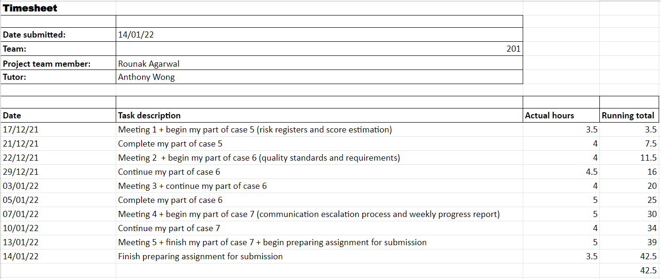

### Laurence Andrews

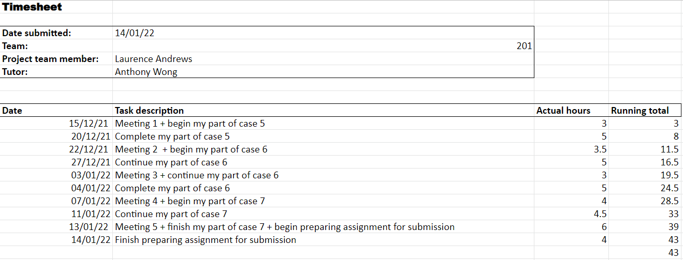

### 

### Neerav Mehta

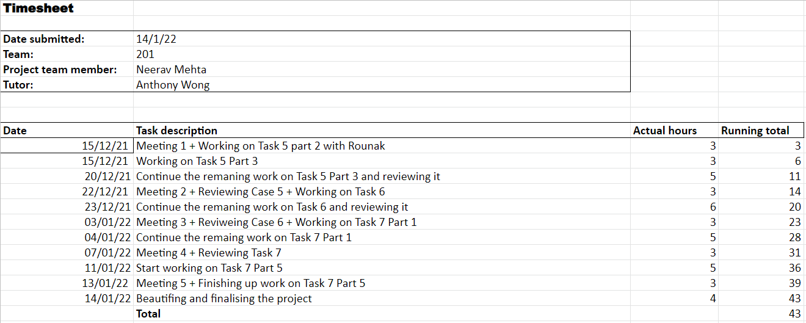

### Timothy Correia-Paul

